**GUJARAT FORENSIC SCIENCES UNIVERSITY**

**INSTITUTE OF MANAGEMENT AND TRAINING**



**MASTER OF BUSINESS ADMINISTRATION**

**IN**

**HOSPITAL AND HEALTHCARE MANAGEMENT**

**EMPIRICAL STUDY OF PREFERENCE AND PATIENT**

**SATISFACTION FOR TELEMEDICINE IN A PANDEMIC 2020**

**SUBMITTED TO:                     SUBMITTED BY:**

**DR. KALGI SHAH                                                                     VISHRA SHAH**

**ASSISTANT PROFESSOR                                                        (000MTMBHC1920005)**

**CONTENTS**

|  |  |
| --- | --- |
| **CHAPTER 1 INTRODUCTION** | **6-7** |
|  |  |
| **CHAPTER 2 LITERATURE REVIEW** | **8-12** |
|  |  |
| **CHAPTER 3 OVERVIEW OF TOPIC** | **13-14** |
|  |  |
| **CHAPTER 4 RESEARCH METHODOLOGY** | **15** |
| **OBJECTIVES** |  |
| **HYPOTHESIS** |  |
| **RESEARCH DESIGN** |  |
| **SAMPLING METHOD** |  |
| **TYPE OF DATA** |  |
| **SAMPLING AREA** |  |
| **SAMPLING SIZE** |  |
|  |  |
| **CHAPTER 5 ANALYSIS** |  |
| **DESCRIPTIVE ANALYSIS** | **16-24** |
| **INFERENTIAL ANALYSIS** | **25-27** |
|  |  |
| **CHAPTER 6 FINDINGS AND CONCLUSION** | **28** |
|  |  |
| **BIBLIOGRAPHY AND ANNEXURE** | **29-32** |

**LIST OF TABLES**

|  |  |  |
| --- | --- | --- |
| **NO.** | **TABLE** | **PAGE NUMBER** |
| **4.1** | **Age (in years)** | **16** |
| **4.2** | **Gender** | **17** |
| **4.3** | **Factors determining satisfaction level in a**  **telemedicine consultation** | **18-19** |
| **4.4** | **Factors determining satisfaction level in**  **Behaviour of telehealth staff** | **20** |
| **4.5** | **Factors determining inconvenience caused in a**  **telemedicine consultation** | **21** |
| **4.6** | **Overall experience of a telemedicine consultation** | **22** |
| **4.7** | **Willingness of participation for another**  **telemedicine consultation** | **23** |
| **4.8** | **Recommendation to others for a telemedicine**  **consultation** | **24** |

**LIST OF CHARTS**

|  |  |  |
| --- | --- | --- |
| **NO.** | **CHARTS** | **PAGE NUMBER** |
| **4.1** | **Age (in years)** | **16** |
| **4.2** | **Gender** | **17** |
| **4.3** | **Factors determining satisfaction level in a**  **telemedicine consultation** | **18-19** |
| **4.4** | **Factors determining satisfaction level in**  **Behaviour of telehealth staff** | **20** |
| **4.5** | **Factors determining inconvenience caused in a**  **telemedicine consultation** | **21** |
| **4.6** | **Overall experience of a telemedicine consultation** | **22** |
| **4.7** | **Willingness of participation for another**  **telemedicine consultation** | **23** |
| **4.8** | **Recommendation to others for a telemedicine**  **consultation** | **24** |

**INTRODUCTION**

The term telemedicine literally means “healing at a distance” through the Latin “medicus” and Greek “tele.” Although there is no single commonly accepted definition of telemedicine, the use of technology to deliver health care services and information at a distance in order to improve access, quality, and cost is a common theme found throughout professional descriptions of these services. According to the American Telemedicine Association, “telemedicine is the use of medical information exchange from one site to another via electronic communications to improve a patient’s clinical health status.” This includes “the use of telecommunications and information technology to provide access to health assessment, diagnosis, interventions, consultation, supervision and information across distance.”

Information and communication technologies (ICTs) have great potential to address some of the challenges faced by both developed and developing countries in providing accessible, cost-effective, high-quality health care services. Telemedicine uses ICTs to overcome geographical barriers, and increase access to health care services. This is particularly beneficial for rural and underserved communities in developing countries – groups that traditionally suffer from lack of access to health care.

Telemedicine can take many different forms. For example, live interactive video and the transfer of electronic information can enable providers to consult with patients, provide diagnoses, and recommend treatment plans. Some telemedicine devices can be used in patients’ homes to collect and send data to health care professionals for analyses and follow-up. In contrast, telehealth services allow consumers to access health education and support for self-management through the Internet, via their home computers or wireless devices. Patients can obtain personalized education materials and coaching and may participate in online discussions and support groups as additional means of managing their health. The proliferation of mobile devices such as mobile phones and tablets has markedly increased consumers’ access to such telehealth services and has given rise to the term mHealth for services accessed through mobile wireless technologies. Given policy makers’ proclivity to debate definitions, it may be more helpful to use the umbrella term “connected health” to encompass this entire family of technologies and services.

During the recent time of COVID-19 pandemic, it has become utmost necessary to switch to telemedicine consultations rather than face-to-face consultation with a healthcare practitioner. COVID has changed the overall healthcare sector right from the grass root level and now these adaptations to change is going to be the new face of the healthcare sector. This will lead to introduction of telemedicine in the daily normal routine of the layman seeking medical and paramedical health facilities. All over the world, the usage of telemedicine has increased over the years but now in these challenging times, the new methods are accepted leading to awareness of telemedicine via different portals.

This project focuses as to how telemedicine is accepted by the people living in one of the biggest cities of Gujarat, India. This project is focused in the vicinity of Ahmedabad and its nearby regions. The main aim is understand the preference of telemedicine, how demographic variables affect it, and the patient satisfaction level among the factors which play a huge role and differs telemedicine from a normal experience of visiting a healthcare practitioner. Factors such as ease of registration of an appointment, effectiveness of the diagnosis, quality of care provided, behaviour of the telehealth staff. It also understands whether they faced any inconvenience such as lack of attention, breach in privacy, getting the prescribed medications and lack of follow-up by the personnel.

By understanding all these factors, one can understand whether a layman really can adapt to the new phase of healthcare sector and how much satisfied he feels at the end of the whole experience.

This project includes literature review of 15 research papers and articles done over the invent

of telemedicine where the study focuses as to how patients are satisfied with the quality of care

they were provided when they opted for telemedicine in different regions of the world and

also as to how physicians and healthcare practitioners who were involved adapted to the different

services of telemedicine such as various websites or apps.

Research methodology concentrates on the objectives and hypothesis of the project which allows as to how demographic variables such as age and gender can affect the patient satisfaction level of the telemedicine. 75 respondents living in the vicinity of Ahmedabad city have submitted the questionnaire and analysis is done on the same. Analysis shows various level of satisfaction among different age groups and gender.

**LITERATURE REVIEW**

|  |  |  |  |  |  |
| --- | --- | --- | --- | --- | --- |
| **AUTHOR/**  **DATE** | **THEORETICAL /CONCEPTUAL FRAMEWORK** | **RESEARCH**  **HYPOTHESIS** | **METHODOLOGY** | **ANALYSIS**  **AND**  **RESULTS** | **CONCLUSIONS** |
| Frances  Mair,  Pamela  Whitten | Review research into patient satisfaction with teleconsultation between healthcare providers and patients involving real time interactive video | Quality of evidence about patient satisfaction | Randomised control  trials  Sample size – 32 | Studies used for  review use the  interactive video  in diverse contexts and demonstrates  feasibility, specialist expertise, less travel required, reduced waiting times | Results also suggest that reliability and validity and  Communication between  Provider and client via the medium are reducing the patient satisfaction. |
| Ace Allen,  Jeannie  Hayes | Patient satisfaction  with telemedicine  in a rural clinic | Patient satisfaction by usage of Interactive televideo communications technology for cost-effectively  improving access to medical care for rural patients | Convenience sampling  Technique  Instrument – Self – administered questionnaire  Sample size – 49 | Analysis assessment showed comfort, ease of access, ability to communicate, overall satisfaction | Results also concluded that some feared of this being replacing the on-site subspecialty clinics but overall it could be a viable alternative to some on-site consultations. |
| Kathyrn Martinez, Nikhyl jhanghinai | Association between  Antibiotic prescribing for respiratory tract infections and patient satisfaction in direct-to-o-consumer telemedicine | Direct to consumer  Telemedicine  is an an ideal setting in which to evaluate the association between antibiotic prescribing for RTIs and satisfaction ratings among patients. | Convenience sampling  Instrument – self- administered questionnaire  Sample size – 8437 | Prescription for an antibiotic received highest patient satisfaction.  Prescribing non-antibiotic medicines may improve satisfaction ratings without unwarranted use of them. | Antibiotic prescribing for RTIs is common and patients who receive antibiotics are more satisfied. |

|  |  |  |  |  |  |
| --- | --- | --- | --- | --- | --- |
| **AUTHOR/**  **DATE** | **THEORETICAL /**  **CONCEPTUAL**  **FRAMEWORK** | **RESEARCH**  **HYPOTHESIS** | **METHODOLOGY** | **ANALYSIS**  **AND**  **RESULTS** | **CONCLUSIONS** |
| Kathyrn Martinez, Nikhyl jhanghinai | Patterns of use and correlates of patients satisfaction with a large nationwide direct to consumer telemedicine service (DTC) | Characterize telemedicine patients and physicians and correlates of patient satisfaction | Research design – Cross-sectional study  Sample size – 24040 patients and 277 physicians | Patient satisfaction with telemedicine physicians, as well as what patients said they would have done had they not accessed the telemedicine system. | Patients were largely satisfied with DTC telemedicine, yet satisfaction varied by coupon use and prescription receipt. |
| Jennifer Polinski, Tobias Parker | Patients satisfaction with and preference for telehealth visits | Rating the satisfaction of seeing diagnostic images, hearing and seeing the remote practitioner, assisting on-site nurses’ capability, quality of care, convenience and understanding. | Research design – cross sectional study with patient satisfaction survey  Sample size – 3303 patients | Patient preferred it over visiting a physician because it saved the time and ranked the teleconsultation as good as visiting the physician. | Patients reported high satisfaction with  their telehealth experience. Convenience and perceived  quality of care were important to patients, suggesting that  telehealth may facilitate access to care. |
| Lori Uscher-Pines,  Ateev Mehrotra | Analysis of Teladoc use seems to indicate expanded access to care for patients without prior connection to a provider | To understand the overall impact of the use of telehealth services on care among a large agency serving public employees across California | Research Design – Cross- sectional study  Sample Size – 2718 CalPERS members | Results indicate that Teladoc providers saw patients with many diagnoses that typically requires an exam, and additional research is needed but it is proven to be cost-effective. | Teladoc is offering a useful and potentially cost-effective service. |

|  |  |  |  |  |  |
| --- | --- | --- | --- | --- | --- |
| **AUTHOR/**  **DATE** | **THEORETICAL/**  **CONCEPTUAL**  **FRAMEWORK** | **RESEARCH**  **HYPOTHESIS** | **METHODOLOGY** | **ANALYSIS**  **AND**  **RESULTS** | **CONCLUSIONS** |
| J. Scott Eastwood,  Ateev Mehrotra | Direct-To-Consumer Teleheath may increase access to care but does not decrease spending | Estimate the changes in utilization and spending associated with direct-to-consumer telehealth visits by comparing first and last telehealth visit. | Research Design – Cohort study  Sample size – Approximately 3,00,000 CalPERS Blue Shield of California health maintenance organisation plan. | Telehealth visits are less expensive per episode suggests that they have the potential to decrease spending and they could save money if greater shares of visits represented substitution for visits to other settings. | Per episode spending was lower if the patient had a direct-to-consumer telehealth visit, compared to an in-person visit. |
| Paul Knudson, Suzanne Meyer | A comparison of diabetes education administered through telemedicine versus in person | Determine whether diabetes education can be through telemedicine technology as through in-person encounters with diabetes nurse and nutrition educators. | Research Design – Case-control  study  Sample size – 56 adults | Patient satisfaction was high in telemedicine group | Diabetes education via telemedicine and in person was equally effective in improving glycemic control and was accepted equally by patients. |

|  |  |  |  |  |  |
| --- | --- | --- | --- | --- | --- |
| **AUTHOR/**  **DATE** | **THEORETICAL/**  **CONCEPTUAL**  **FRAMEWORK** | **RESEARCH**  **HYPOTHESIS** | **METHODOLOGY** | **ANALYSIS**  **AND**  **RESULTS** | **CONCLUSIONS** |
| R Chua, J Craig | Randomised controlled trial of telemedicine for new neurological outpatient referrals | Telemedicine for new patient referrals to neurological outpatients is as efficient and acceptable as conventional face to face consultation. | A randomised controlled trial having a face to face and telemedicine group  Sample size – 168 patients | Patients were satisfied with both types of consultation process except for concerns of confidentiality and embarrassment in the telemedicine group | Telemedicine for the new neurological outpatients is possible and feasible but generates more investigations and is less well accepted than face to face examination. |
| Noriaki Aoki,  Kim Dunn | Outcomes and Methods in Telemedicine Evaluation | To understand as to how and in which areas can telemedicine be effective by using various methodologies | Sample size – 104 articles | Clinical outcomes, Accuracy, Cost effectiveness, diagnostic accuracy, technical outcomes, non-clinical evaluation lead to understanding of different telemedicine approaches and methods used. | Future research can undoubtedly  improve telemedicine programs and may encourage  potential telemedicine providers to initiate  such services. |
| Nathan Hare, Priya Bansal | COVID-19: Unmasking telemedicine-  Convenience of care, Increased access, and cost savings | ----- | ---------- | --------- | Telemedicine has been shown to increase access to and  decrease the cost of medical care |
| 2020 | Patient satisfaction with telemedicine encounters in an allergy and immunology practice during COVID-19 | Understanding the difference during pandemic between in- person and telemedicine consultations | Sample size – 95 patients  Self- administered questionnaire  Tool – Stata software | Patient satisfaction was achieved through telemedicine | Patient care outcomes are comparable with telemedicine  vs in-person visits and that telemedicine can result  in cost savings |

|  |  |  |  |  |  |
| --- | --- | --- | --- | --- | --- |
| **AUTHOR/**  **DATE** | **THEORETICAL/**  **CONCEPTUAL**  **FRAMEWORK** | **RESEARCH**  **HYPOTHESIS** | **METHODOLOGY** | **ANALYSIS**  **AND**  **RESULTS** | **CONCLUSIONS** |
| 2020 | Feasibility of telemedicine in maintaining follow-up of orthopaedic patients and their  satisfaction: A preliminary study | Analyze the effectiveness of proactive telemedicine in maintaining follow-up  of orthopedic patients, and their satisfaction with telemedicine as an alternative mode of  treatment  delivery. | Research design –  Cross-sectional study    Self-administered  questionnaire  Sample size – 620  patients | The overall  satisfaction-rate to telemedicine was 92% and only 7.2% of patients had difficulty in  understanding or following telemedicine-based advice. | Telemedicine can effectively reduce the need for physical visits to  Outpatient-departments for follow up of orthopedic patients. The response-rate and overall  Patient-satisfaction rates to telemedicine are high. |
| S. Pavlopoulos  E. Kyriacou | A novel emergency telemdecine system based on wireless communication technology – “AMBULANCE” | A portable medical device, that allows telediagnosis, long distance support, and teleconsultation of mobile health care providers by experts located at an emergency coordination centre or a specialized hospital. | Self –administered  questionnaire  Sample size – 100 | A portable medical device to be used for emergency telemedicine applications. The device allows the collection and transmission of vital biosignals, still images of the patient and bi-directional telepointing capability. | The advance man-machine enhances the system functionality by allowing the paramedics to operate in hands-free mode while receiving data and communicating with specialists in a hospital. |
| Harman  Rahal  Long le, | Patient Satisfaction and Healthcare Utilization Using Telemedicine in Liver Transplant Recipients | Assess whether telemedicine can be utilised to overcome barriers to care whole sustaining strong patient-physician relationships | Sample size – 21 patients  Patient satisfaction questionnaire  Research Design -  Case control study | Telemedicine patients were satisfied with communication and interpersonal approach compared to clinic patients and experience less commute which opted them to use the service again | Telemedicine appeared to be both a time and cost-saving alternative to clinic follow-up without compromise of the valuable patient-physician. |

**OVERVIEW OF THE TOPIC**

Telemedicine, a term coined in the 1970s, which literally means “healing at a distance”, signifies the use of Information and Communication Technologies (ICT) to improve patient outcomes by increasing access to care and medical information.

Recognizing that there is no one definitive definition of *telemedicine* – a 2007 study found

104 peer-reviewed definitions of the word – the World Health Organization has adopted the following broad description:

*“The delivery of health care services, where distance is a critical factor, by all health care professionals using information and communication technologies for the exchange of valid information for diagnosis, treatment and prevention of disease and injuries, research and evaluation, and for the continuing education of health care providers, all in the interests of advancing the health of individuals and their communities”.*

Four elements are germane to telemedicine:

1. To provide clinical support.

2. It is intended to overcome geographical barriers, connecting users who are not in the

same physical location.

3. It involves the use of various types of ICT.

4. Its goal is to improve health outcomes.

The replacement of analogue forms of communication with digital methods, combined with a rapid drop in the cost of ICTs, have sparked wide interest in the application of telemedicine among health-care providers, and have enabled health care organizations to envision and implement new and more efficient ways of providing care. The introduction and popularization of the Internet has further accelerated the pace of ICT advancements, thereby expanding the scope of telemedicine to encompass Web-based applications (e.g. e-mail, teleconsultations and conferences via the Internet) and multimedia approaches (e.g. digital imagery and video). These advancements have led to the creation of a rich tapestry of telemedicine applications that the world is coming to use.

Telemedicine applications can be classified into two basic types, according to the timing of the information transmitted and the interaction between the individuals involved—be it health

Professional-to-health professional or health professional-to-patient. Store-and-forward, or asynchronous, telemedicine involves the exchange of pre-recorded data between two or more individuals at different times. For example, the patient or referring health professional sends an e-mail description of a medical case to an expert who later sends back an opinion regarding diagnosis and optimal management. In contrast, real time, or synchronous, telemedicine requires the involved individuals to be simultaneously present for immediate exchange of information, as in the case of videoconferencing. In both synchronous and asynchronous telemedicine, relevant information may be transmitted in a variety of media, such as text, audio, video, or still images. These two basic approaches to telemedicine are applied to a wide array of services in diverse settings, including teledermatology, telepathology, and teleradiology.

The majority of telemedicine services, most of which focus on diagnosis and clinical management. In addition, biometric measuring devices such as equipment monitoring heart rate, blood pressure and blood glucose levels are increasingly used to remotely monitor and manage patients with acute and chronic illnesses. Some predict that telemedicine will profoundly transform the delivery of health services in the industrialized world by migrating health care delivery away from hospitals and clinics into homes.

In low-income countries and in regions with limited infrastructure, telemedicine applications

are primarily used to link health-care providers with specialists, referral hospitals, and tertiary

care centres. Even though low-cost telemedicine applications have proven to be feasible,

clinically useful, sustainable, and scalable in such settings and underserved communities, these applications are not being adopted on a significant scale due to a variety of barriers.

Telemedicine holds great potential for reducing the variability of diagnoses as well as improving clinical management and delivery of health care services worldwide by enhancing access, quality, efficiency, and cost-effectiveness. In particular, telemedicine can aid communities traditionally underserved – those in remote or rural areas with few health services and staff –because it overcomes distance and time barriers between health-care providers and patients. Further, evidence points to important socioeconomic benefits to patients, families, health practitioners and the health system, including enhanced patient-provider communication and educational opportunities.

Despite its promise, telemedicine applications have achieved varying levels of success. In both industrialized and developing countries, telemedicine has yet to be consistently employed in the health care system to deliver routine services, and few pilot projects have been able to sustain themselves once initial seed funding has ended.

One such challenge is a complex of human and cultural factors. Some patients and health care workers resist adopting service models that differ from traditional approaches or indigenous practices, while others lack ICT literacy to use telemedicine approaches effectively. Most challenging of all are linguistic and cultural differences between patients (particularly those underserved) and service providers. As public and private sectors engage in closer collaboration and become increasingly interdependent in eHealth applications, care must be taken to ensure that telemedicine will be deployed intelligently to maximize health services and optimal quality and guarantee that for-profit endeavours do not deprive citizens access to fundamental public health services.

In all countries, issues pertaining to confidentiality, dignity, and privacy are of ethical concern with respect to the use of ICTs in telemedicine. It is imperative that telemedicine be implemented equitably and to the highest ethical standards, to maintain the dignity of all individuals and ensure that differences in education, language, geographic location, physical and mental ability, age, and sex will not lead to marginalization of care.

**RESEARCH METHODOLOGY**

* **CHAPTER –4.1 : OBJECTIVE**
* Understand the preference of telemedicine consultation in the times of a pandemic
* To check the impact of demographic variables on preference and patient satisfaction on telemedicine
* **CHAPTER -4.2 : HYPOTHESIS**
* There is no significant difference between age groups of the respondents and factors

affecting preference for telemedicine

* There is no significant difference between age groups of the respondents and behaviour

of the teleheath staff

* There is no significant difference between age groups of the respondents and inconvenience

caused in the telemedicine consultation

* There is no significant difference between gender of the respondents and factors

affecting preference for telemedicine

* There is no significant difference between gender of the respondents and behaviour

of the teleheath staff

* There is no significant difference between gender of the respondents and inconvenience

caused in the telemedicine consultation

* **CHAPTER 4.3 -RESEARCH DESIGN**
* **SAMPLING METHOD**
* Convenience sampling
* **TYPE OF DATA**
* Primary Data from self-administered questionnaire and secondary data from research

papers and articles

* **DATA COLLECTION TOOL**
* Online Questionnaire

* **SAMPLING AREA**
* City of Ahmedabad and surrounding areas
* **SAMPLING SIZE**
* 75 Respondents

**ANALYSIS**

**DESCRIPTIVE ANALYSIS**

**Age(in years)**

**Table 4.1**

|  |  |  |
| --- | --- | --- |
| Age | Frequency | Percentage % |
| 0-20 years | 7 | 9.3 % |
| 21-30 years | 20 | 26.7% |
| 31-40 years | 2 | 2.7% |
| 41-50 years | 15 | 20% |
| 51-60 years | 18 | 24% |
| 61-70 years | 5 | 6.7% |
| 71 years and above | 8 | 10.7% |
| Total | 75 |  |

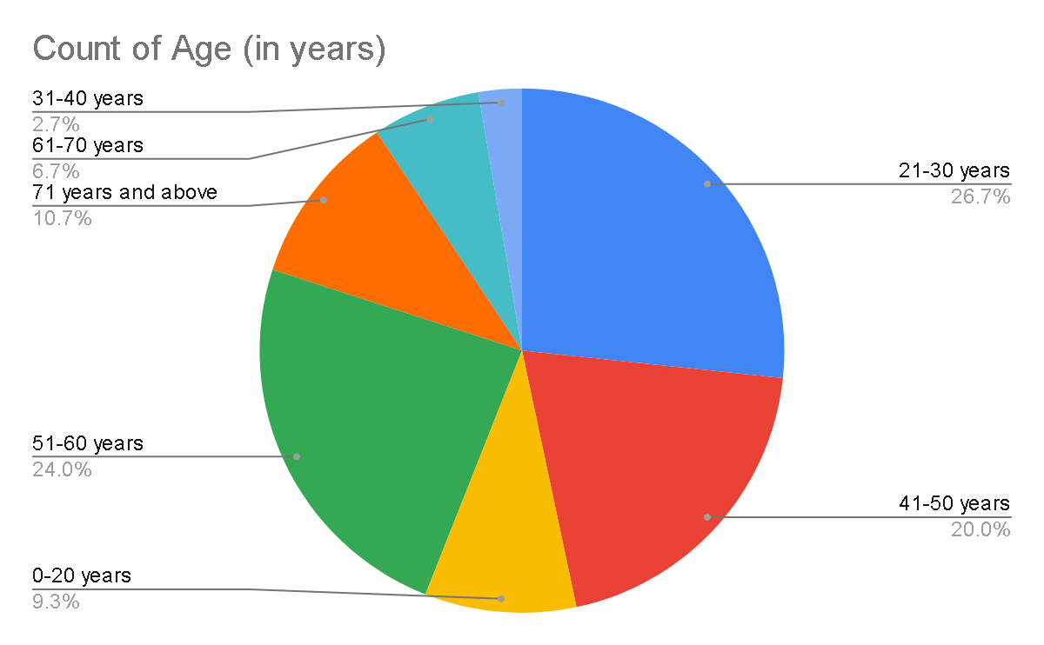

Analysis

Above pie graph 4.1 depicts age distributions of respondents. It is divided among 7 distinct age groups. Highest number of respondents with percentage distribution of 26.7% belongs to the age of group of 21-30 years. The next level of 24% percentage distribution belongs to the age group from 51-60 years. The next level belongs to 41-50 years having 20% percentage distribution and rest of the respondents belongs to other age groups.

|  |  |  |
| --- | --- | --- |
| Gender | Frequency | Percentage % |
| Male | 28 | 37.3% |
| Female | 47 | 62.7% |
| Others | 0 | 0 |
| Total | 75 |  |

**Gender**

**Table 4.2**

**Chart 4.2**

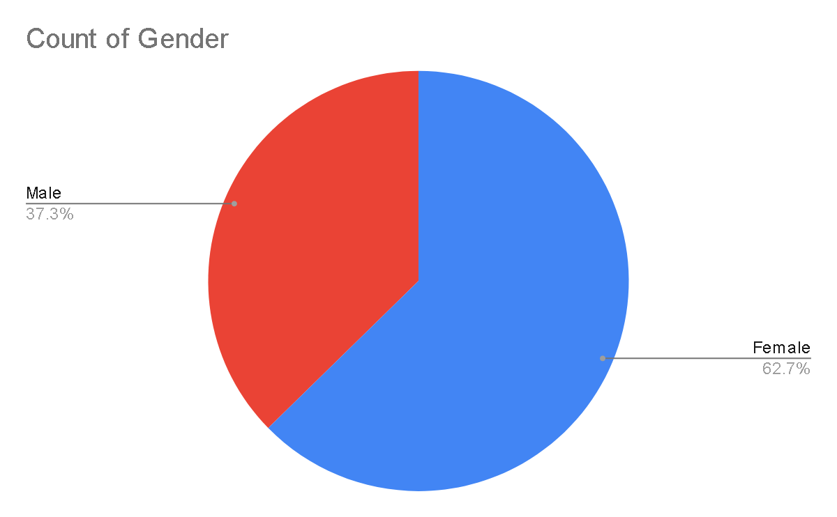

**Analysis**

Above pie graph 4.2 depicts the Gender distribution of respondents whereas out of the total number of respondents, female respondents were more than male respondents by 25.4%.

**Table 4.3**

|  |  |  |  |  |  |  |  |  |  |  |  |  |
| --- | --- | --- | --- | --- | --- | --- | --- | --- | --- | --- | --- | --- |
|  | **Ease of getting registered/**  **scheduled** | | **Quality of Audio** | | **Quality of Video** | | **Effectiveness**  **of**  **the**  **diagnosis** | | **Ease in talking**  **With**  **the**  **concerned**  **practitioner** | | **Quality of care provided** | |
|  | **Frequency** | **%** | **Frequency** | **%** | **Frequency** | **%** | **Frequency** | **%** | **Frequency** | **%** | **Freq**  **uency** | **%** |
| **Very Satisfied** | 32 | 42.7% | 28 | 37.3% | 19 | 25.3% | 37 | 49.3% | 41 | 54.7% | 40 | 53.3% |
| **Satisfied** | 34 | 45.3% | 41 | 54.7% | 45 | 60% | 31 | 41.3% | 28 | 37.3% | 28 | 37.3% |
| **Neutral** | 9 | 12% | 6 | 8% | 10 | 13.3% | 7 | 9.3% | 6 | 8% | 7 | 9.3% |
| **Dissatisfied** | 0 | 0 | 0 | 0 | 1 | 1.3% | 0 | 0 | 0 | 0 | 0 | 0 |
| **Very Dissatisfied** | 0 | 0 | 0 | 0 | 0 | 0 | 0 | 0 | 0 | 0 | 0 | 0 |
| **Total** | 75 |  | 75 |  | 75 |  | 75 |  | 75 |  | 75 |  |

**Chart 4.3**

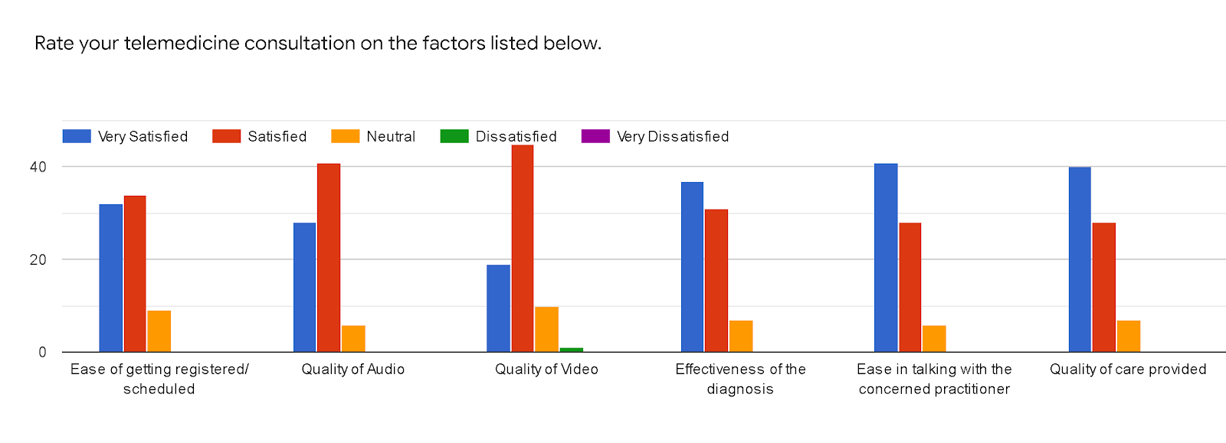

**Analysis**

The above table and graph 4.3 shows as to how the respondents have rated their satisfaction level for the factors provided such as 42.7% respondents are very satisfied with the way they could get their appointment scheduled, 37.3% and 25.3% were very satisfied with quality of audio and video while talking to a healthcare personnel, whereas 49.3% respondents found that the diagnosis which they received over a telemedicine consultation was accurate, 54.7% respondents found that the concerned practitioner were easy to approach and they could easily talk to them about the health concerns and 53.3% respondents got the care which they were expecting from their teleheath personnel which made them really satisfied with the overall telemedicine consultation.

**Table 4.4**

|  |  |  |  |  |  |  |  |  |
| --- | --- | --- | --- | --- | --- | --- | --- | --- |
|  | **Courtesy** | | **Respect** | | **Sensitivity** | | **Friendliness** | |
|  | **Frequency** | **%** | **Frequency** | **%** | **Frequency** | **%** | **Frequency** | **%** |
| **Very Satisfied** | 34 | 45.3% | 31 | 41.3% | 33 | 44% | 36 | 48% |
| **Satisfied** | 31 | 41.3% | 36 | 48% | 34 | 45.3% | 31 | 41.3% |
| **Neutral** | 9 | 12% | 7 | 9.3% | 8 | 10.7% | 7 | 9.3% |
| **Dissatisfied** | 1 | 1.3% | 1 | 1.3% | 0 | 0 | 1 | 1.3% |
| **Very Dissatisfied** | 0 | 0 | 0 | 0 | 0 | 0 | 0 | 0 |
| **Total** | 75 |  | 75 |  | 75 |  | 75 |  |

**Chart 4.4**

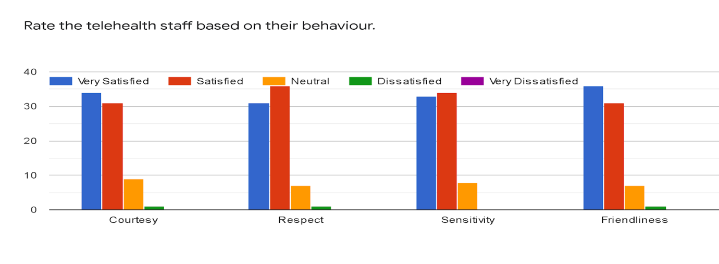

**Analysis**

The above table and chart 4.4 shows that respondents have rated the teleheath staff based on their behaviour. 45.3% respondents were very satisfied with the way the staff was courteous towards them, 41.3% respondents were very satisfied with the way staff respected them and 44% and 48% respondents were very satisfied with the staff’s sensitivity towards their complaint and their friendliness towards them. Almost 1.35% respondents were dissatisfied with the staff’s behaviour towards them. While all other respondents felt satisfied and were comfortable with the behaviour of the staff in their telemedicine consultation.

**Table 4.5**

|  |  |  |  |  |  |  |  |  |  |  |  |  |
| --- | --- | --- | --- | --- | --- | --- | --- | --- | --- | --- | --- | --- |
|  | **Waiting period to get in contact with the concerned practitioner** | | **Lack of attention by the personnel** | | **Neglect in asking for past medical history** | | **Breach in Privacy** | | **Difficulty in getting the prescribed medications** | | **Lack of follow-up by the personnel** | |
|  | **Frequency** | **%** | **Frequency** | **%** | **Frequency** | **%** | **Frequency** | **%** | **Frequency** | **%** | **Freq**  **uency** | **%** |
| **1** | 34 | 45.3% | 37 | 49.3% | 37 | 49.3% | 40 | 53.3% | 37 | 49.3% | 36 | 48% |
| **2** | 32 | 42.6% | 27 | 36% | 29 | 38.6% | 25 | 33.3% | 29 | 38.6% | 28 | 37.3% |
| **3** | 4 | 5.3% | 6 | 8% | 5 | 6.6% | 3 | 4% | 5 | 6.6% | 7 | 9.3% |
| **4** | 3 | 4% | 2 | 2.6% | 1 | 1.3% | 2 | 2.6% | 2 | 2.6% | 2 | 2.6% |
| **5** | 2 | 2.6% | 3 | 4% | 3 | 4% | 5 | 6.6% | 2 | 2.6% | 2 | 2.6% |
| **Total** | 75 |  | 75 |  | 75 |  | 75 |  | 75 |  | 75 |  |

**Chart 4.5**

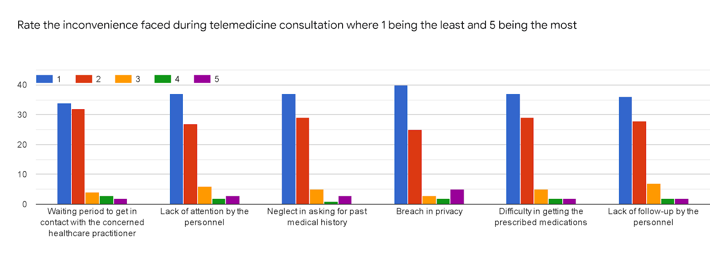

**Analysis**

Table and chart 4.5 shows the inconvenience which were faced by the respondents during their telemedicine consultation. 2.6% respondents faced difficulty in contacting their concerned practitioner as their waiting period was prolonged, 4% respondents experienced lack of attention by the personnel during the consultation which made caused them inconvenience, 4% respondents experienced neglect from the staff/practitioner because they did not ask for the respondent’s past medical history, 6.6% respondents felt a breach in their privacy by the personnel whereas 2.6% respondents felt difficulty in getting the prescribed medications and a lack of follow-up by the personnel hence causing inconvenience and lack of satisfaction during a telemedicine consultation.

**Table 4.6**

|  |  |  |
| --- | --- | --- |
| **Overall experience of telemedicine and telehealth consultation** | | |
|  | **Frequency** | **%** |
| **Very Satisfied** | 34 | 45.3% |
| **Satisfied** | 34 | 45.3% |
| **Neutral** | 7 | 9.3% |
| **Dissatisfied** | 0 | 0 |
| **Very Dissatisfied** | 0 | 0 |
| **Total** | 75 |  |

**Chart 4.6**

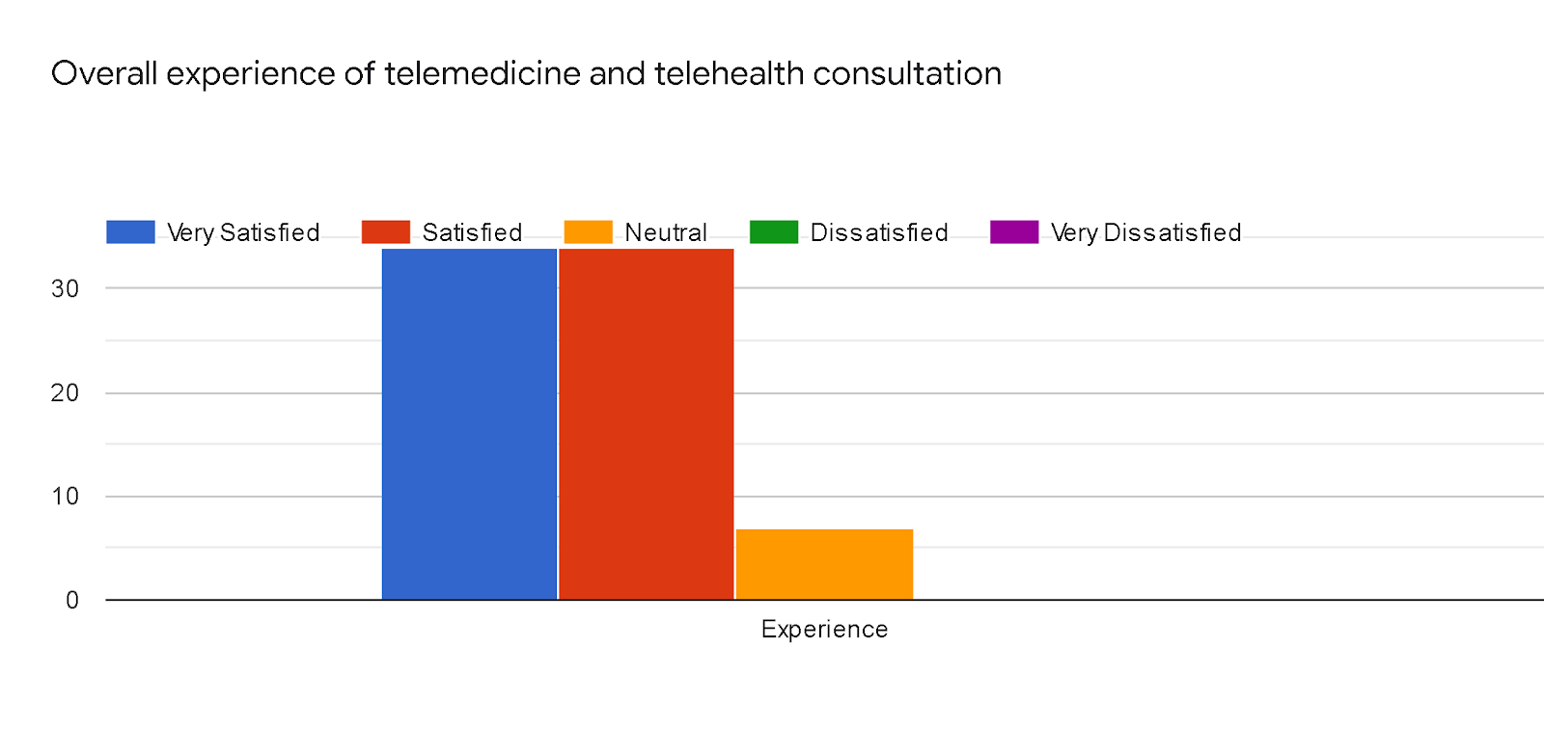

**Analysis**

The above table and graph 4.6 shows that 45.3% respondents were very satisfied with the overall

experience of the telemedicine and telehealth consultation whereas rest of the 45.3% respondents were

satisfied and about 9.3% were comfortable enough with the overall experience.

**Table 4.7**

|  |  |  |
| --- | --- | --- |
| **Willingness of participation in another telemedicine consultation** | | |
|  | **Frequency** | **%** |
| **Yes** | 60 | 80% |
| **No** | 5 | 6.7% |
| **Maybe** | 10 | 13.35 |
| **Total** | 75 |  |

**Chart 4.7**

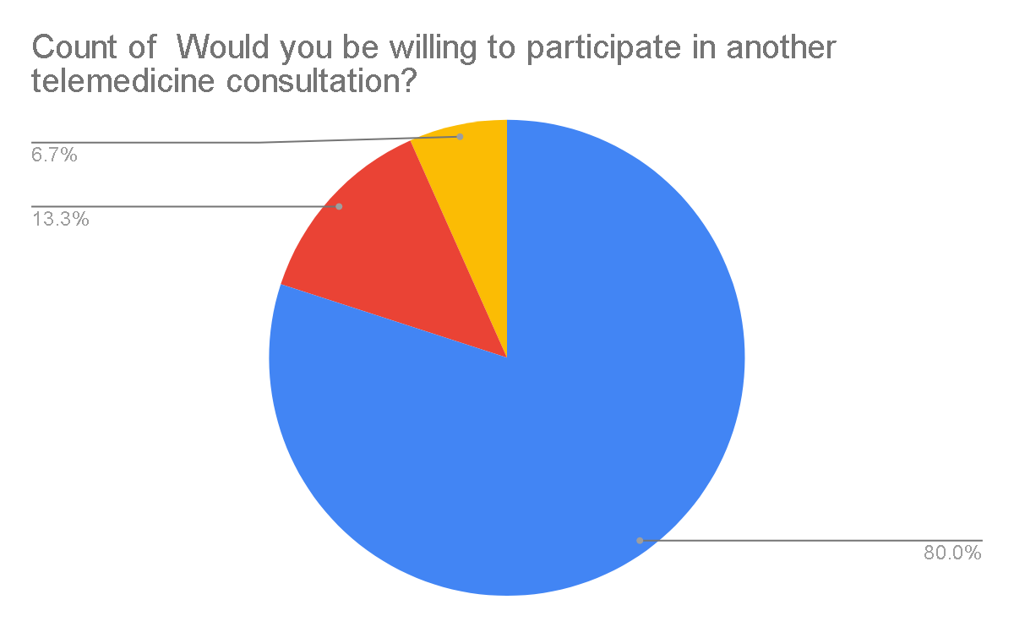

**Analysis**

The above pie graph 4.7 shows that the 80% respondents were willing to participate in a

Telemedicine consultation whereas 6.7% respondents will not participate again, whereas

13.35% respondents were perplexed about whether to participate for another telemedicine

consultation.

**Table 4.8**

|  |  |  |
| --- | --- | --- |
| **Recommendation to others for a telemedicine consultation** | | |
|  | **Frequency** | **%** |
| **Yes** | 66 | 88% |
| **No** | 4 | 5.3% |
| **Maybe** | 5 | 6.7% |
| **Total** | 75 |  |

**Chart 4.8**

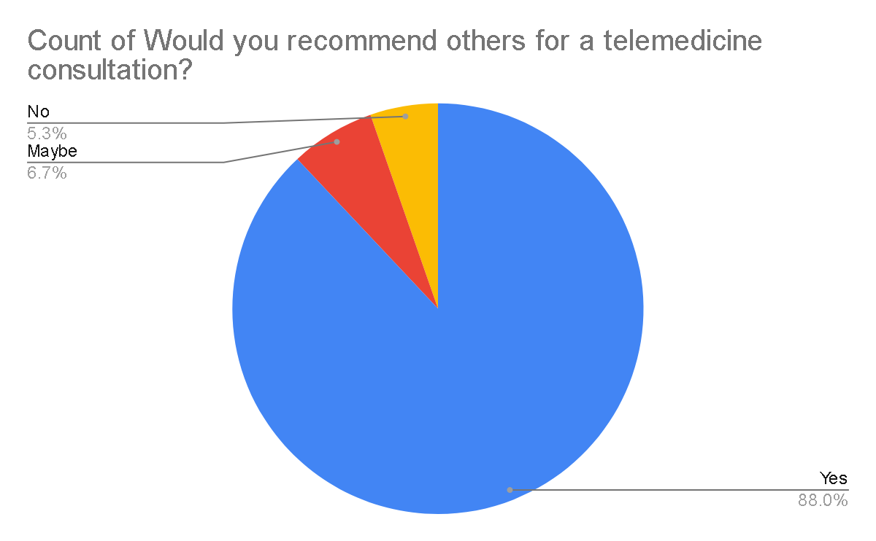

**Analysis**

The above pie graph 4.8 shows that 88% of those who participated in a telemedicine consultation were ready to recommend others for the same whereas, 5.3% were not willing and 6.7% respondents were perplexed of recommending others for a telemedicine consultation.

**INFERENTIAL ANALYSIS**

**ANOVA ANALYSIS**

|  |  |  |  |
| --- | --- | --- | --- |
| **Factor name** | **Sig.** | **Decisions** | |
| Ease of getting registered  / scheduled | .000 | Null hypothesis not accepted | 0-20 years, 21-30 years, 41-50 years, 51-60 years, 61-70 years,71 years and above |
| Quality of Audio | .004 | Null hypothesis not accepted | 21-30 years, 51-60 years |
| Quality of Video | .070 | Null hypothesis not accepted | 21-30 years, 51-60 years |
| Effectiveness of the diagnosis | .000 | Null hypothesis not accepted | 0-20 years, 21-30 years, 51-60 years,71 years and above |
| Ease in talking with the concerned practitioner | .000 | Null hypothesis not accepted | 0-20 years, 21-30 years,41-50 years, 51-60 years, 61-70 years,71 years and above |
| Quality of care provided | .000 | Null hypothesis not accepted | 0-20 years, 21-30 years,31-40 years, 41-50 years, 51-60 years, 61-70 years,71 years and above |
| Courtesy as shown by the telehealth staff | .000 | Null hypothesis not accepted | 0-20 years, 21-30 years,51-60 years, 61-70 years |
| Respect as shown by the telehealth staff | .000 | Null hypothesis not accepted | 0-20 years, 21-30 years,51-60 years, 61-70 years |
| Sensitivity as shown by the telehealth staff | .000 | Null hypothesis not accepted | 0-20 years, 21-30 years,51-60 years, 61-70 years |
| Friendliness as shown by the telehealth staff | .000 | Null hypothesis not accepted | 0-20 years, 21-30 years, 41-50 years, 51-60 years, 61-70 years,71 years and above |
| Inconvenience faced by the respondents – Waiting period to get in contact with the concerned healthcare practitioner | .001 | Null hypothesis not accepted | 21-30 years, 51-60 years, 71 years and above |
| Inconvenience faced by the respondents – Lack of attention by the personnel | .000 | Null hypothesis not accepted | 21-30 years, 41-50 years, 51-60 years, 61-70 years,71 years and above |
| Inconvenience faced by the respondents –-Neglect in asking for past medical history | .000 | Null hypothesis not accepted | 21-30 years, 41-50 years, 51-60 years, 61-70 years,71 years and above |
| Inconvenience faced by the respondents –- Breach in privacy | .000 | Null hypothesis not accepted | 21-30 years, 41-50 years, 51-60 years, 61-70 years,71 years and above |
| Inconvenience faced by the respondents –-Difficulty in getting the prescribed medications | .000 | Null hypothesis not accepted | 21-30 years, 41-50 years, 51-60 years, 61-70 years,71 years and above |
| Inconvenience faced by the respondents –-Lack of follow-up by the personnel | .002 | Null hypothesis not accepted | 21-30 years, 51-60 years,71 years and above |

**T- TEST ANALYSIS**

|  |  |  |
| --- | --- | --- |
| **Factors** | **Significant value** | **Decisions** |
| Ease of getting registered / scheduled | .676 | Null hypothesis accepted |
| Quality of Audio | .507 | Null hypothesis accepted |
| Quality of Video | .204 | Null hypothesis accepted |
| Effectiveness of the diagnosis | .495 | Null hypothesis accepted |
| Ease in talking with the concerned practitioner | .553 | Null hypothesis accepted |
| Quality of care provided | .320 | Null hypothesis accepted |
| Courtesy as shown by the telehealth staff | .576 | Null hypothesis accepted |
| Respect as shown by the telehealth staff | .442 | Null hypothesis accepted |
| Sensitivity as shown by the telehealth staff | .685 | Null hypothesis accepted |
| Friendliness as shown by the telehealth staff | .505 | Null hypothesis accepted |
| Inconvenience faced by the respondents – Waiting period to get in contact with the concerned healthcare practitioner | .491 | Null hypothesis accepted |
| Inconvenience faced by the respondents – Lack of attention by the personnel | .973 | Null hypothesis accepted |
| Inconvenience faced by the respondents –-Neglect in asking for past medical history | .832 | Null hypothesis accepted |
| Inconvenience faced by the respondents –- Breach in privacy | .295 | Null hypothesis accepted |
| Inconvenience faced by the respondents –-Difficulty in getting the prescribed medications | .982 | Null hypothesis accepted |
| Inconvenience faced by the respondents –-Lack of follow-up by the personnel | .768 | Null hypothesis accepted |

**FINDINGS AND CONCLUSIONS**

**FINDINGS**

* 75 respondents living in and the vicinity of Ahmedabad where 26.7% respondents belong to the age group of 21-30 years and 24% respondents belong to the age group of 51-60 years.
* 62.7% respondents are females whereas rest of them are males.
* Respondents have rated their satisfaction level for the factors provided with the way they could get their appointment scheduled, quality of audio and video while talking to a healthcare personnel, diagnosis which they received over a telemedicine consultation, respondents found that the concerned practitioner were easy to approach and they could easily talk to them about the health concerns and also got the care which they were expecting from their teleheath personnel which made them really satisfied with the overall telemedicine consultation.
* Respondents rated the behaviour of telehealth staff on the basis of courtesy, respect, sensitivity and friendliness. 1% of the respondents were dissatisfied with the behaviour whereas other respondents were more or less satisfied with the behaviour and help they got from the telehealth staff.
* Inconvenience such as difficulty in contacting their concerned practitioner as their waiting period was prolonged, lack of attention by the personnel during the consultation , neglect from the staff/practitioner because they did not ask for the respondent’s past medical history, a breach in their privacy by the personnel whereas respondents also rated whether they felt difficulty in getting the prescribed medications and a lack of follow-up by the personnel hence causing inconvenience and lack of satisfaction during a telemedicine consultation.
* Respondents were overall really satisfied with the telemedicine consultation and they were most of them were willing to participate again for a consultation and also recommend it to others.

**CONCLUSIONS**

* ANOVA analysis shows that different age groups are satisfied in different factors but two age groups ranging from 21-30 years and 51-60 years are those who are not completely satisfied with the telemedicine consultation and hence causing the variation in the patient satisfaction levels.
* T-test analysis shows that there is no significant difference in satisfaction levels in telemedicine consultation between males and females.

**BIBLIOGRAPHY AND ANNEXURE**

**RESEARCH PAPERS AND ARTICLES**

* World Health Organization. (2010). *Telemedicine: opportunities and developments in member states. Report on the second global survey on eHealth*. World Health Organization.
* Hollander, J. E., & Carr, B. G. (2020). Virtually perfect? Telemedicine for COVID-19. *New England Journal of Medicine*, *382*(18), 1679-1681.
* Mair, F., & Whitten, P. (2000). Systematic review of studies of patient satisfaction with telemedicine. *Bmj*, *320*(7248), 1517-1520.
* Allen, A., & Hayes, J. (1994). Patient satisfaction with telemedicine in a rural clinic. *American Journal of Public Health*, *84*(10), 1693-1693.
* Collins, K., Nicolson, P., & Bowns, I. (2000). Patient satisfaction in telemedicine. *Health Informatics Journal*, *6*(2), 81-85.
* Martinez, K. A., Rood, M., Jhangiani, N., Kou, L., Boissy, A., & Rothberg, M. B. (2018). Association between antibiotic prescribing for respiratory tract infections and patient satisfaction in direct-to-consumer telemedicine. *JAMA internal medicine*, *178*(11), 1558-1560.
* Martinez, K. A., Rood, M., Jhangiani, N., Kou, L., Rose, S., Boissy, A., & Rothberg, M. B. (2018). Patterns of use and correlates of patient satisfaction with a large nationwide direct to consumer telemedicine service. *Journal of general internal medicine*, *33*(10), 1768-1773.
* Kvedar, J., Coye, M. J., & Everett, W. (2014). Connected health: a review of technologies and strategies to improve patient care with telemedicine and telehealth. *Health affairs*, *33*(2), 194-199
* Polinski, J. M., Barker, T., Gagliano, N., Sussman, A., Brennan, T. A., & Shrank, W. H. (2016). Patients’ satisfaction with and preference for telehealth visits. *Journal of general internal medicine*, *31*(3), 269-275.
* Uscher-Pines, L., & Mehrotra, A. (2014). Analysis of Teladoc use seems to indicate expanded access to care for patients without prior connection to a provider. *Health Affairs*, *33*(2), 258-264.
* Ashwood, J. S., Mehrotra, A., Cowling, D., & Uscher-Pines, L. (2017). Direct-to-consumer telehealth may increase access to care but does not decrease spending. *Health Affairs*, *36*(3), 485-491.
* Schwamm, L. H. (2014). Telehealth: seven strategies to successfully implement disruptive technology and transform health care. *Health Affairs*, *33*(2), 200-206.
* Izquierdo, R. E., Knudson, P. E., Meyer, S., Kearns, J., Ploutz-Snyder, R., & Weinstock, R. S. (2003). A comparison of diabetes education administered through telemedicine versus in person. *Diabetes care*, *26*(4), 1002-1007.
* Aoki, N., Dunn, K., Johnson-Throop, K. A., & Turley, J. P. (2003). Outcomes and methods in telemedicine evaluation. *Telemedicine Journal and e-Health*, *9*(4), 393-401.
* Chua, R., Craig, J., Wootton, R., & Patterson, V. (2001). Randomised controlled trial of telemedicine for new neurological outpatient referrals. *Journal of Neurology, Neurosurgery & Psychiatry*, *71*(1), 63-66.
* Hare, N., Bansal, P., Bajowala, S. S., Abramson, S. L., Chervinskiy, S., Corriel, R., ... & Rupp, M. R. (2020). COVID-19: Unmasking Telemedicine. *The Journal of Allergy and Clinical Immunology: In Practice*.
* Mustafa, S. S., Yang, L., Mortezavi, M., Vadamalai, K., & Ramsey, A. (2020). Patient Satisfaction with Telemedicine Encounters in an Allergy/Immunology Practice During the COVID-19 Pandemic. *Annals of Allergy, Asthma & Immunology*.
* Pavlopoulos, S., Kyriacou, E., Berler, A., Dembeyiotis, S., & Koutsouris, D. (1998). A novel emergency telemedicine system based on wireless communication technology-AMBULANCE. *IEEE Transactions on information technology in biomedicine*, *2*(4), 261-267.
* Kumar, S., Kumar, A., Kumar, M., Kumar, A., Arora, R., & Sehrawat, R. (2020). Feasibility of telemedicine in maintaining follow-up of orthopaedic patients and their satisfaction: A preliminary study. *Journal of Clinical Orthopaedics and Trauma*.
* Le, L. B., Rahal, H. K., Viramontes, M. R., Meneses, K. G., Dong, T. S., & Saab, S. (2019). Patient satisfaction and healthcare utilization using telemedicine in liver transplant recipients. *Digestive diseases and sciences*, *64*(5), 1150-1157..**ANNEXURE**

1. **Name**: ____________________
2. **Age (in years)**: 0-20 years ( ), 21-30 years ( ), 31-40 years ( ), 41-50 years ( ),

51-60 years ( ), 61-70 years ( ), 71 years and above ( )

1. **Gender** : Female ( ), Male ( ), Others ( )
2. **Rate your telemedicine consultation on the factors listed below.**

|  |  |  |  |  |  |
| --- | --- | --- | --- | --- | --- |
|  | **Very**  **Satisfied** | **Satisfied** | **Neutral** | **Dissatisfied** | **Very**  **Dissatisfied** |
| **Ease of getting registered/**  **scheduled** |  |  |  |  |  |
| **Quality of Audio** |  |  |  |  |  |
| **Quality of Video** |  |  |  |  |  |
| **Effectiveness of**  **the diagnosis** |  |  |  |  |  |
| **Ease in talking**  **with the**  **concerned**  **practitioner** |  |  |  |  |  |
| **Quality of care**  **provided** |  |  |  |  |  |

1. **Rate the telehealth staff based on their behaviour.**

|  |  |  |  |  |  |
| --- | --- | --- | --- | --- | --- |
|  | **Very**  **Satisfied** | **Satisfied** | **Neutral** | **Dissatisfied** | **Very**  **Dissatisfied** |
| **Courtesy** |  |  |  |  |  |
| **Respect** |  |  |  |  |  |
| **Sensitivity** |  |  |  |  |  |
| **Friendliness** |  |  |  |  |  |

1. **Rate the inconvenience faced during telemedicine consultation where 1 being the least and 5 being the most**

|  |  |  |  |  |  |
| --- | --- | --- | --- | --- | --- |
|  | **1** | **2** | **3** | **4** | **5** |
| **Waiting period to get in contact with the concerned healthcare practitioner** |  |  |  |  |  |
| **Lack of attention by the personnel** |  |  |  |  |  |
| **Neglect in asking for past medical history** |  |  |  |  |  |
| **Breach in privacy** |  |  |  |  |  |
| **Difficulty in getting the prescribed medications** |  |  |  |  |  |
| **Lack of follow-up by the personnel** |  |  |  |  |  |

1. **Overall experience of telemedicine and telehealth consultation**

|  |  |  |  |  |  |
| --- | --- | --- | --- | --- | --- |
|  | **Very**  **Satisfied** | **Satisfied** | **Neutral** | **Dissatisfied** | **Very**  **dissatisfied** |
| **Experience** |  |  |  |  |  |

1. **Would you be willing to participate in another telemedicine consultation?**

Yes ( ), No ( ), Maybe ( )

1. **Would you recommend others for a telemedicine consultation?**

Yes ( ), No ( ), Maybe ( )